Requirements Document

Body Mass Index Calculator

SEP Example - 2014

Preface
This chapter should define the expected readership of the document.
Describe its version history, rational for this version and changes since the last version.

This document will outline a simple body mass index calculator, intended as a working example for students undertaking the Software Engineering Principles Module. The document is intended for potential users/sponsors of the application and the development team.

Version History

Version numbering – versions prior to 1.0 are development versions.

Version 0.1 -

Introduction
A brief description of the need for the system, how it will work and how it fits into the existing system or market place.

The Body Mass Calculator system is being developed as part of a suite of programs designed to target the growing target market of health concious computer users in the United Kingdom. The body mass index or BMI is a measure for adults that provides an indication of healthy weight for an individuals height [1].

For most adults a healthy or ideal BMI is in the 18.5-24.9 range. A BMI of 25 or more, suggests an individual weights more than the ideal for their height [1]:

- 25-29.9 is overweight
- 30-39.9 is obese
- 40 or more is very obese

A BMI of less than 18.5, suggests an individual weighs less than the ideal for their height.

BMI is calculated via a simple formula BMI = (weight / height ) / height. Where the weight is in kilograms (kg) and the height in meters (m).

Being overweight or obese can increase your risk of health problems, such as [1]:

- Heart disease
- Stroke
- Type 2 diabetes
- Some types of cancer
- High blood pressure (hypertension)
- Kidney disease

Being underweight can also increase your risk of health problems, such as [1]:

- Brittle bones (osteoporosis)
- Absent periods in women (amenorrhoea)
- Iron deficiency anaemia

As well as measuring your BMI, healthcare professionals may take other factors into account when assessing weight [1]. Muscle weighs more than fat. Very muscular people, such as heavyweight boxers, weight trainers and athletes, may be a healthy weight even though their BMI is classed as obese. Ethnic group can also affect your risk of some health conditions. For example, adults of Asian origin may have a higher risk of health problems at BMI levels below 25. Users must be made aware of these limitations before using the program.

Glossary
Defines any technical terms which may be unfamiliar to the reader

BMI – Body Mass Index

Legal and Ethical Issues
Outline any legal or ethical concerns which impact on the project, provide detail of the various laws. These should manifest in the system requirements

Ethical Issues
It must be made clear that there are limitation to the BMI reading given by the calculator, while it gives some indication of an individuals height/weight ration in comparison to what is considered healthy by the medical profession this is subject to interpretation. The product must carry a warning to this effect.

Legal Issues
As the application will not store personal data, there are no data protection concerns. There is however the potential for this application to cause harm. Incorrect information given to a user could cause stress or in an extreme case unnecessary dieting or weight gain, testing will need to be rigours to ensure this is not the case. A warning should also be issued if an individual is outside the normal limits suggesting that they should consult their doctor before undertaking and weight loss or gain program.

User Requirements Definition
The services provided to the user both functional and non-functional requirements

Functional Requirements

1.0 User Interface

The program needs a simple to use user graphical interface.

Rational: A user interface is essential for the target market, they are unlikely to be comfortable with command line tools.

Specification: Section xx
Source: Glenn L. Jenkins, MH310

1.1 Form

A form based interface will be require similar to that used in other applications developed for current desktop operating systems.

Rational: There are a large number of form based applications both in commercial and home user software, while a more exotic interface is technically feasible familiarity will enable users to make immediate use of the application.

Specification: Section xx
Source: Glenn L. Jenkins, MH310

1.2 User Input

The user will need a to be able to input their weight and height for the BMI calculation.

Rational: The calculation cannot be completed without input from the user, this will need to be subjected to a number of validation tests.

Specification: Section xx
Source: Glenn L. Jenkins, MH310

1.2.1 Weight Input Validation

The weight will need to be in kilograms and within sensible defined limits.

Rational: Numerical extremes may cause the system to crash, e.g. zero (which will cause a divide by zero error). There are extremes of both weight and height which can safely be interpreted as errors.

Specification: Section xx
Source: Glenn L. Jenkins, MH310

1.2.1.1 Weight Input Validation Error

If the weight entered is not within the correct limits and error must be produced and the users input should be cleared.

Rational: The program must report to the user when they have entered incorrect information.

Specification: Section xx
Source: Glenn L. Jenkins, MH310

1.2.2 Height Input Validation

The weight will need to be in kilograms and within sensible defined limits.

Rational: Numerical extremes may cause the system to crash, e.g. zero (which will cause a divide by zero error). There are extremes of both weight and height which can safely be interpreted as errors.

Specification: Section xx
Source: Glenn L. Jenkins, MH310

1.2.2.1 Height Input Validation Error

If the height entered is not within the correct limits and error must be produced and the users input should be cleared.

Rational: The program must report to the user when they have entered incorrect information.

Specification: Section xx
Source: Glenn L. Jenkins, MH310

1.2.3 Weight Input Mechanism

The weight will be input via a text box, this will be clearly labelled and have a tab order of 0. Users will be able to edit this box.

Rational: A text box is easy for the user to manipulate and allows users the freedom to enter text at the keyboard.

Specification: Section xx
Source: Glenn L. Jenkins, MH310

1.2.4 Alternative Weight Units

The application may offer alternative units for weight.

Rational: Not everyone knows their weight in both kilograms and stones and pounds, offering the ability to switch between units increases the chances of a user having the necessary information to hand to use our application.

Specification: Section xx
Source: Glenn L. Jenkins, MH310

1.2.5 Height Input Mechanism

The height will be input via a text box, this will be clearly labelled and have a tab order of 1. Users will be able to edit this box.

Rational: A text box is easy for the user to manipulate and allows users the freedom to enter text at the keyboard.

Specification: Section xx
Source: Glenn L. Jenkins, MH310

1.2.6 Alternative Height Units

The application may offer alternative units for height.

Rational: Not everyone knows their height in meters and feet and inches, offering the ability to switch between units increases the chances of a user having the necessary information to hand to use our application.

Specification: Section xx
Source: Glenn L. Jenkins, MH310

1.3 BMI Output Mechanism

The calculated BMI will displayed in a text box, this will be clearly labelled. It will have no tab order and will not be editable by the user.

Rational: Using a text box provides a common look for the height, weight and BMI on screen. A text field could be used but it would look different to the other boxes on screen.

Specification: Section xx
Source: Glenn L. Jenkins, MH310

1.4 BMI Numerical Output Mechanism

The calculated BMI will displayed in a text box, this will be clearly labelled. It will have no tab order and will not be editable by the user.

Rational: Using a text box provides a common look for the height, weight and BMI on screen. A text field could be used but it would look different to the other boxes on screen.

Specification: Section xx
Source: Glenn L. Jenkins, MH310

1.5 BMI Textural Output Mechanism

A label underneath the text box will provide a classification based on those used on the NHS website [1]:
- less than 18.5 is less than is ideal for your height
- 25-29.9 is overweight
- 30-39.9 is obese
- 40 or more is very obese

Rational: This provides an interpretation of the BMI score to the user.

Specification: Section xx
Source: Glenn L. Jenkins, MH310

1.5.1 Low/High BMI warning

Any indication of a Low/High BMI and the classification should be accompanied by a disclaimer which indicates that the BMI is flawed for certain body types etc.

Rational: This will hopefully limit our liability.

Specification: Section xx
Source: Glenn L. Jenkins, MH310

1.6 Calculate Button

The calculate button triggers the one action of the application, to calculate the BMI based on the inputs. This will also undertake the validation of the from input and generation of the form output.

Rational: Using a text box provides a common look for the height, weight and BMI on screen. A text field could be used but it would look different to the other boxes on screen.

Specification: Section xx
Source: Glenn L. Jenkins, MH310

1.6.1 Calculate Button Activation

The calculate button should only be activated when the weight and height fields contain valid input.

Rational: Limiting the use of the calculate button reduces the risk of incorrect input being fed into the BMI, also the button becoming active after entering eight and weight gives the user an indication what to do next.

Specification: Section xx
Source: Glenn L. Jenkins, MH310

1.6.2 Calculate Button Highlight

In addition to becoming active the button my change its label or colour to indicate that it is ready to perform the calculation.

Rational: This will aid the user in following the steps required to use the application.

Specification: Section xx
Source: Glenn L. Jenkins, MH310

2.0 BMI Calculation

The calculation of the BMI is undertaken based on the following formula.

BMI = (weight / height ) / height

Rational: The BMI is calculated based on the entered weight and height, these should have been suitable validated the output is an integer.

Specification: Section xx
Source: Glenn L. Jenkins, MH310

Non-Functional Requirements

3.0 Medical style

The application should have medical look.

Rational: The application should look medical, this will hopefully inspire trust and encourage people to use the app.

Specification: Section xx
Source: Glenn L. Jenkins, MH310

3.1 Colour

The application should 'medical' looking colours to emphasise its links to BMI and a healthy lifestyle.

Rational: The application must use similar colours to those found in other medical applications, to emphasise its links to BMI and a healthy lifestyle. These vary with nationality. Given that the application is based on UK government data the scheme could follow that of the NHS website.

Specification: Section xx
Source: Glenn L. Jenkins, MH310

3.1 Font

The application should 'medical' looking fonts.

Rational: The application must use similar fonts to those found in other medical applications, to emphasise its links to BMI and a healthy lifestyle. These vary with nationality. Given that the application is based on UK government data the scheme could follow that of the NHS website.

Specification: Section xx
Source: Glenn L. Jenkins, MH310

4.0 Easy of Use

The application should be easy to use

Rational: A use should be able to use the application with minimal on screen instruction. This is essential if the application is to be adopted by a broad range of users.

Specification: Section xx
Source: Glenn L. Jenkins, MH310

4.1 Labelling

Labelling must be clear and instructive

Rational: Labels used on buttons and text boxes should give a clear indication of their function

Specification: Section xx
Source: Glenn L. Jenkins, MH310

4.1 Label Text

Height textbox - “Enter your height -”
Weight textbox - “Enter your weight-”
BMI button - “Calculate BMI”

Rational: Labels used on buttons and text boxes should give a clear indication of their function

Specification: Section xx
Source: Glenn L. Jenkins, MH310

5.0 Target Operating System

The application should be cross platform.

Rational: Developing for many platforms provides more opportunities, while Windows is still the largest market for applications it is also a very crowded market place. Emerging markets such as iOS and Linux offer the possiblity of a greater share of a smaller market.

Specification: Section xx
Source: Glenn L. Jenkins, MH310

System Architecture
A high level overview of the system, how it will interact with existing systems.
The distribution of functionality across the architecture and components which will be reused should be highlighted.

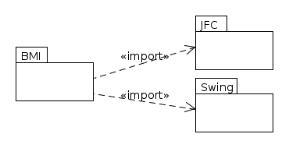

Systems Requirements Specification
Describes the functional and non functional requirements in more detail

1.0 Windowing API

The system should use a windowing API to draw a window to the screen. This will provide the canvas for the form based application.

1.1 Render Components

The windowing API must be able to render elements onto the form.

1.1.1 Render Form

The Windowing API must be capable for rendering a form to screen.

1.1.2 Render Button

The Windowing API must be capable for rendering a button to screen.

1.1.3 Render Label

The Windowing API must be capable for rendering a label to screen.

1.1.3 Render Textbox

The Windowing API must be capable for rendering a text box to screen.

1.3 User Interaction

The API must provide facilities for the user to interact with the form and its components

1.3.1 Button Interaction

The button should provide the interaction expected by the user.

1.3.2 Button click

When clicked the button should (by the mechanism used by the API) cause the code associated with the button to run. Clicking the button also makes it selected.

1.3.3 Button Selection

Button can be the current selection (as a text box can), it should show this by changing its appearance.

1.3.3 Button Enter/Return click

A selected button can be clicked by the user pressing either the enter key or return key.

1.3.4 Button Tab

If a button is selected and the tab key is hit, the selection should move to the component with the next highest tab order.

1.4.1 Text box Interaction

The text box should provide familiar interaction mechanisms to the user

1.4.1.1 Text box Selection

When clicked the text box should become active a cursor should be shown and the text box ready to receive text input from the keyboard.

1.4.1.2 Text box Typing

When the text box is selected the characters entered at the keyboard should appear in the text box.

1.4.1.3 Text box Tab

If a text box is selected and the tab key is hit, the selection should move to the component with the next highest tab order.

1.5 Render Label

Windowing API must be capable of rending a text based label which can be changed at runtime.

2.0 Validity checking

Data from the text box must be validated, validity checking is undertaken each time the user enters a key. No error message is given but the BMI calculation button does not become active until the valid input is entered.

2.1 Height text box validity checking

Height must be between:
* 0.1 meters and 3 meters or
* 1' 0” and 8' 0”

2.2 Weight text box validity checking

Weight must be between:
* 10 Kg and 100 Kg or
* 1st 8lb and 15st 10lb

3.0 Data types

Data types of the variables

3.1 BMI – floating point number

3.2 Height
* floating point if meters
* two integers for feet and inches

3.3 Weight
* floating point for kilograms
* two integers for stones and pounds

5.0 Respond to BMI button click

The system must respond to the BMI button being clicked.

5.1 Response pseudo-code

1. Check input validity
2 If invalid show error message
3. Calculate BMI
4 If error show error message
5. Display BMI (numerical)
6. Display BMI (interpretation – text).

5.1.1 Validation failure

The system should report any failure in validation. Validation should be completed when the button is clicked.

Error message: Will depend on the kind of error, to give maximum information to the user, this will be composed of the following - “BMI cannot be calculated the information provided is incorrect” - default message followed by a more specific error string (as shown below).

Error | Message
Height is not in the valid range | “Please enter a height within the valid range”
Height is not entered | “Please enter your height”
Height is not numerical | “Please enter your height in numerical format e.g. 1.5”
Weight is not in the valid range | “Please enter a weight within the valid range”
Weight is not entered | “Please enter your weight”
Weight is not numerical | “Please enter your weight in numerical format e.g. 79”

5.1.2 Calculation failure

In the case of an internal error i.e. there being no detected issue with the inputs but the system failing anyway the application should display a message indicating the a bug has been encountered.

Error message: “Error in BMI calculation please report this to the vendor”

6.0 Display BMI

The application must display the BMI of the individual in both numerical form and with appropriate guidance for its interpretation.

6.1 Display Numerical BMI

The system must output the numerical BMI by setting the text of an appropriately placed label.

6.2 Display Textural BMI

The system must display a suitable output along with the BMI to aid interpretation, by setting the text of an appropriately placed label.

BMI Range | Label Content
less than 18.5 | Your BMI is less than is ideal for your height
25-29.9 | Your BMI suggests you are overweight
30-39.9 | Your BMI suggests you are obese
40 or more | Your BMI suggests you are very obese

Scenarios
A set of one or more scenarios describing the anticipated use of the system.

Sunny Day Scenario

The user opens the application and enters their height in meters and weight in kilograms into the text boxes (these are marked to indicate which should go where). The user presses the calculate button and their numerical BMI and a textual interpretation of this (as shown above) is provided.

Height Validation Failure

The user opens the application and enters their height in meters and weight in kilograms into the text boxes (these are marked to indicate which should go where). The user presses the calculate button and an error message appears indicating the the height is incorrectly entered. This results in an appropriate error message, comprised of the stock validation error message and one of the extension messages shown below.

Error | Message
Height is not in the valid range | “Please enter a height within the valid range”
Height is not entered | “Please enter your height”
Height is not numerical | “Please enter your height in numerical format e.g. 1.5”

Weight Validation Failure

The user opens the application and enters their height in meters and weight in kilograms into the text boxes (these are marked to indicate which should go where). The user presses the calculate button and an error message appears indicating the the height is incorrectly entered. This results in an appropriate error message, comprised of the stock validation error message and one of the extension messages shown below.

Error | Message
Weight is not in the valid range | “Please enter a weight within the valid range”
Weight is not entered | “Please enter your weight”
Weight is not numerical | “Please enter your weight in numerical format e.g. 79”

BMI calculation Failure

The user opens the application and enters their height in meters and weight in kilograms into the text boxes (these are marked to indicate which should go where). The user presses the calculate button and their numerical BMI and an error message is shown.

Error | Message
Unknown error | “An error has occurred, please contact the application vendor”

Given the nature of the system it is not envisaged that this simple calculation can go wrong provided it is given appropriate inputs.

System Models
A set of one or more models describing the desired system, showing relationships between system components and between the system and its environment.

NOTE: I've used both use case documents and sequence diagrams, some companies use either or both, I'd like examples of both for your projects to demonstrate your understanding.

Sunny Day Scenario
The following diagrams relate to the sunny day scenario.

Sunny Day – Usecase Diagram

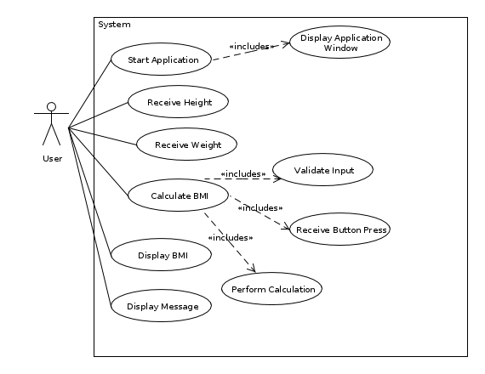

Sunny Day – Sequence Diagram

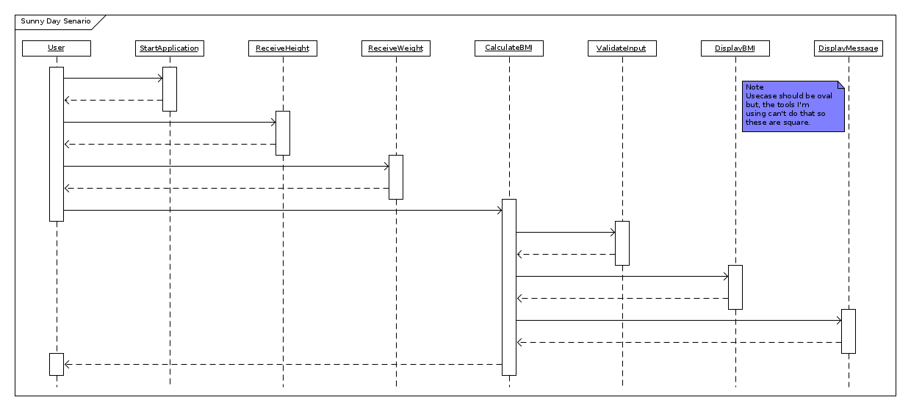

Height / Weight Validaton Senaiors

Combined for clarity as there are a number of shared elements.

Height / Weight validation error – Usecase

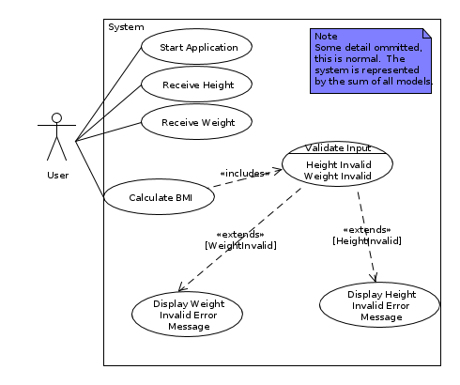

Height / Weight validation error – Sequence Diagram
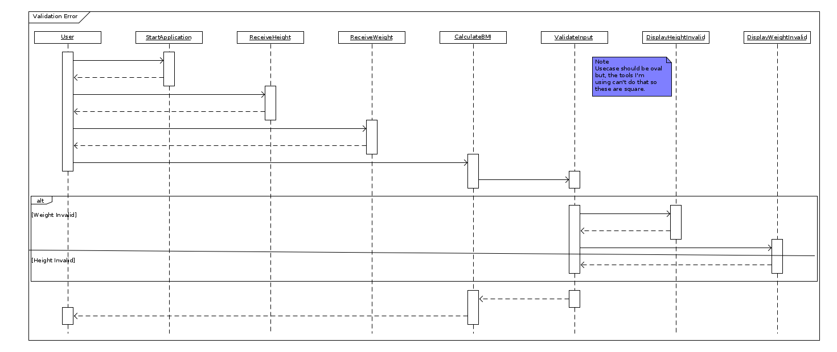

BMI Calculation Failure

Diagrams related to faiure of the BMI calculation.

BMI Calculation Failure – Usecase

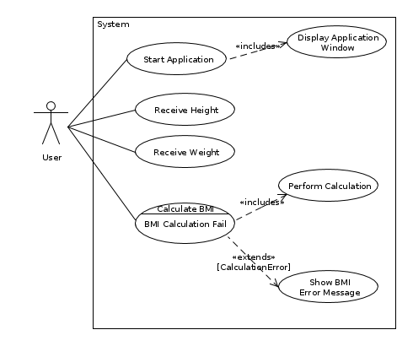

BMI Calculation Failure – Usecase Document

Scenario: 3 | Scenario Name: BMI Calculation Failure
Goal: Show the results of a failure in the BMI calculations
Description: The user interfaces with the system but something goes wrong and the calculation cannot be completed. This may be a user input error which is not caught by the validation, an out of memory error or a logical error not discovered in testing.
Actors: User
Frequency of Execution: This should never happen if there are no logical errors in our application and there is no reason for our machine to run out of memory or have other serious issues.
Scalability: One user maximum
Criticality: It is essential that in the case of unknown errors we handle them gracefully, this will give a good impression to the user. Information regarding the issue should be presented if possible.
Other non-functional requirements: Message must be informative and provide the user with some insight into the cause of the crash (this will also aid our bug tracking).
Primary path: The following sequence is carried out for each customer who wants to withdraw money.
1. User starts application
2. The user interface is displayed on screen
2. User inputs their height in the height text box
3. User inputs their weight in the weight text box
4. User clicks the calculate BMI button
5. The user input is validated
6. The BMI Calculation fails
7. An error message is shown

Use cases related to primary path: Start Application, Display Application Window, Receive Height, Receive Weight, Calculate BMI, Perform Calculation,
Alternatives (to primary path):
6.1 Calculation succeeds – see Sunny Day use case
6.2 BMI is displayed
6.3 Message is displayed

Use cases related to alternate path: Display BMI, Display Message

Further Decomposition
Having produced usecase diagrams for the seanrios identified there are a number of usecase which we can further expand by behavioural decomposition. These are Show Message, User Input and Show Application.

Show Appliation – Usecase Diagram

This shows the behaviours the system must be cable of to succesfully show the window, there is no implied order and hence no sequence diagram or usecase document.
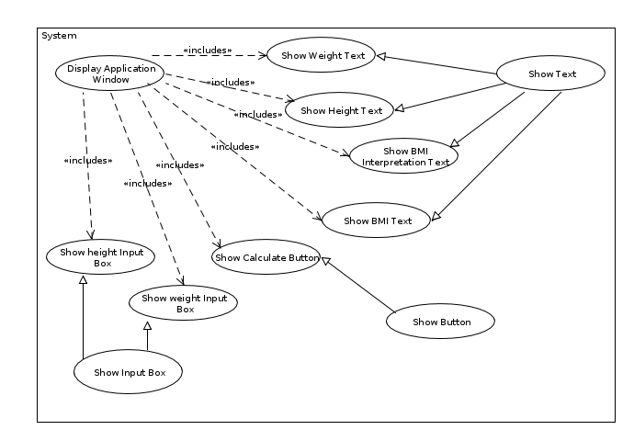
User Input – Usecase Diagram

This diagram servers to demonstrate the key elements of interaction required by the system, i.e. typed input and the ability to receive button clicks from the interface.
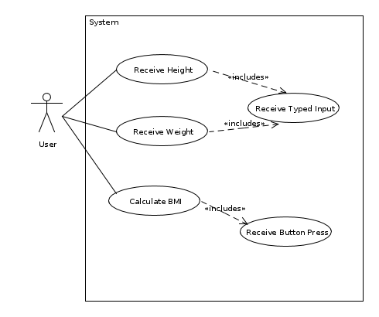
Displaying Messages – Usecase Diagrams

This usecase diagram helps show the functionaltiy required to convey information to the user, essentially the ability to show a message (composed of text is key). This can be concidered core functionality as without this we are unable to communicate with the user.
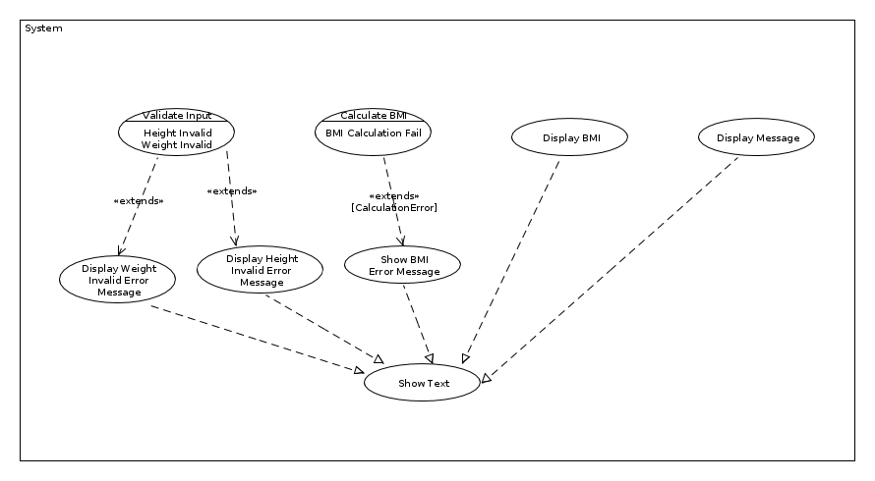

Domain Object Model
The diagram attemtps to show the objects in our problem domain we beleive are required in the design domain. *This will evolve into the class diagrm.

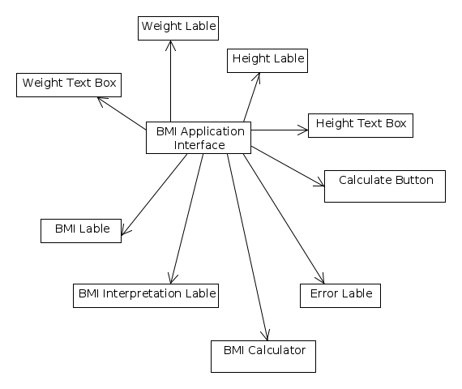

Assumptions
Describe the assumptions the system is based

It is assumed that the sytsem will be built using a framework or set of libraries to provide a portion of the applications behaivour. This will proivde much of the functionality connected to displaying the application on screen (its buttons, boxes etc.) and displaying messages. In the design these will be assocated with a 3rd party package.

System Evolution
Describe the anticipated changes with regard to business needs, hardware evolution etc.

There are no anticipated changes at this stage.

Appendices
Detailed specific information about the system, such as hardware descriptions, database descriptions, minimal system requirements etc.

Index
Indices of diagrams figures as well as an alphabetic index may be included.

References

[1] NHS Direct Website, http://www.nhs.uk/chq/Pages/3215.aspx?CategoryID=51

